In The Name of God



Navid Zare (40435071)

Neural Networks and Deep Learning
Assignment 4: GCN-Transformer for Molecular Learning

Abstract
This report presents a dual-view deep learning system that learns aligned molecular representations from two complementary modalities: a molecular-graph view encoded with a Graph Convolutional Network (GCN) and a sequence view encoded with a causal Transformer language model operating on SELFIES strings. The two encoders are trained jointly with a symmetric contrastive objective supplemented by a positive-pair cosine term, so that the graph and sequence embeddings of the same molecule occupy a shared representation space. The Transformer is additionally trained for next-token prediction, enabling autoregressive generation of new molecules, which are filtered through a nine-stage chemical validation pipeline. All experiments use the MoleculeNet Lipophilicity dataset. After preprocessing, 4,194 unique molecules were retained. The trained system achieves strong cross-modal alignment, with test-set Top-1 retrieval accuracy of 0.821 (graph-to-sequence) and 0.831 (sequence-to-graph) and a mean rank near 1.35, against a random-chance Top-1 of 0.0024. Sampling at three temperatures produces molecules with 100% SELFIES/RDKit validity and acceptance rates between 0.787 and 0.933, with acceptance decreasing and the mean drug-likeness (QED) declining as sampling temperature increases. The results confirm that the graph and sequence views can be aligned effectively, while also highlighting that formal validity of generated molecules does not by itself guarantee chemical plausibility.

1. Introduction
Molecular property prediction and de novo molecular design are central problems in computational chemistry and drug discovery. A molecule can be represented in several equivalent ways, most commonly as a two-dimensional graph, in which atoms are nodes and bonds are edges, or as a linear string such as SMILES or SELFIES. Each representation exposes different inductive biases: graph models capture local connectivity and topology directly, whereas sequence models capture long-range syntactic regularities of the string encoding. Learning a representation in which these two views agree is valuable because it couples the structural information of the graph with the generative flexibility of the sequence model.
The objective of this assignment is to build and evaluate a system that
- Constructs a clean molecular dataset from the MoleculeNet Lipophilicity collection
- Encodes each molecule both as a graph, using a Graph Convolutional Network, and as a SELFIES sequence, using a Transformer language model
- Aligns the two views in a shared embedding space through contrastive learning
- generates novel molecules with the Transformer and validates them with a rigorous cheminformatics pipeline.
The central research questions are therefore whether the two modalities can be aligned so that the embedding of a molecule in one view retrieves its counterpart in the other, and whether the generative model produces molecules that are not only formally valid but also chemically plausible and novel.
The remainder of this report is organized as follows. Section 2 describes the methodology, including dataset preparation, graph and sequence encoders, the training objective, the generation procedure, and the validation pipeline. Section 3 presents all quantitative and visual results. Section 4 provides a detailed analysis and interpretation of each result. Section 5 concludes and discusses limitations and future work.

2. Methodology

2.1 Dataset Preparation
The raw dataset contains 4,200 molecules, each specified by a ChEMBL identifier, an experimental lipophilicity value, and a SMILES string. Preparation follows a deterministic pipeline. Every SMILES is parsed and sanitized with RDKit; molecules that fail parsing are discarded. Valid molecules are converted to canonical isomeric SMILES, which provides a unique string per structure and thereby enables reliable duplicate detection. Duplicate canonical structures are removed. Each remaining molecule is converted to a SELFIES string, a representation that is robust by construction because every SELFIES string decodes to a syntactically valid molecule. Sequences longer than 100 symbols are discarded to bound the Transformer context length. The surviving molecules are shuffled with a fixed random seed and partitioned into training, validation, and test splits in an approximate 80/10/10 ratio. Finally, a token vocabulary is constructed from the training split only, augmented with four special tokens: a padding token, a beginning-of-sequence token, an end-of-sequence token, and an unknown token. Building the vocabulary from the training split alone prevents information leakage from the validation and test sets.

2.2 Molecular Graph Construction
Each molecule is converted to a graph in which nodes correspond to atoms and undirected bonds are represented as pairs of directed edges. Every atom is described by seven categorical fields: element, degree, formal charge, hybridization, aromaticity, total number of attached hydrogens, and chirality. Rather than concatenating one-hot vectors, each field indexes a dedicated learnable embedding table, and the seven embeddings are summed to form the initial atom representation; this keeps the input dimensionality fixed and lets the model learn field-specific representations. Bond order is encoded as a scalar edge weight, with single, double, triple, and aromatic bonds mapped to 1.0, 2.0, 3.0, and 1.5 respectively, so that the graph convolution can modulate message strength by bond type.

2.3 Graph Convolutional Encoder
The graph encoder is a three-layer Graph Convolutional Network. Each layer applies a graph convolution that aggregates neighbor features using the symmetric normalization of the GCN, weighted by the scalar bond weights, followed by a ReLU non-linearity, batch normalization, dropout, and a residual connection. The per-layer update is given in Equation 1, where the summation runs over the neighborhood of atom i including a self-loop, $w_{ij}$is the bond weight, and the degree terms provide the standard symmetric normalization.
$$h_{i}^{\left(l+1\right)}=\text{Drop}\left(\text{BN}\left(\text{ReLU}\left(\sum_{j∈N\left(i\right)∪\left\{i\right\}}{\frac{w_{ij}}{\sqrt{{\overset{ˆ}{d}}_{i}{\overset{ˆ}{d}}_{j}}}}W^{\left(l\right)}h_{j}^{\left(l\right)}\right)\right)\right)+h_{i}^{\left(l\right)}$$

After three propagation layers, a permutation-invariant graph-level embedding is obtained by global mean pooling over atoms, and this pooled vector is passed through a two-layer projection head and L2-normalised, as shown in Equation 2. The resulting unit-norm vector is the graph representation used for contrastive alignment.
$$z_{G}=\text{L2}\left(\text{MLP}\left(\frac{1}{\left|V\right|}\sum_{i∈V}{h_{i}^{\left(L\right)}}\right)\right)$$

2.4 Transformer Sequence Model
The sequence encoder is a four-layer Transformer with six attention heads, a model width of 192, and a feed-forward width of 512. Token embeddings and learned positional embeddings are summed at the input. A causal (upper-triangular) attention mask ensures that position t attends only to positions up to t, and a padding mask excludes padded positions. The model is trained as an autoregressive language model with the next-token objective of Equation 3, where the target sequence is the input shifted by one position and padded positions are ignored in the loss.
$$L_{\text{token}}=-\frac{1}{T}\sum_{t=1}^{T}{{\log{p}}_{θ}}\left(x_{t}∣x_{<t}\right)$$
For the purpose of cross-modal alignment, the hidden state at the end-of-sequence position summarizes the entire molecule; it is passed through a separate two-layer projection head and L2-normalised to obtain the sequence representation of Equation 4.
$$z_{S}=\text{L2}\left(\text{MLP}\left(h_{\text{eos}}\right)\right)$$

2.5 Cross-Modal Alignment Objective
Alignment is enforced with a symmetric contrastive (InfoNCE) loss computed over each mini-batch. For a batch of B molecules, the graph and sequence embeddings form a B-by-B similarity matrix; the matching graph-sequence pair on the diagonal is treated as the positive and all other in-batch pairs as negatives, in both the graph-to-sequence and sequence-to-graph directions, as defined in Equation 5. A temperature parameter tau scales the similarities.
$$L_{\text{con}}=-\frac{1}{2B}\sum_{i=1}^{B}{\left[\log{\frac{\exp\left(s_{ii}/τ\right)}{\sum_{j}{\exp\left(s_{ij}/τ\right)}}}+\log{\frac{\exp\left(s_{ii}/τ\right)}{\sum_{j}{\exp\left(s_{ji}/τ\right)}}}\right]}, s_{ij}=z_{G,i}^{⊤}z_{S,j}$$
To directly encourage corresponding representations to coincide, an additional positive-pair cosine loss (Equation 6) penalizes the angular distance between the graph and sequence embeddings of the same molecule.
$$L_{\text{pair}}=\frac{1}{B}\sum_{i=1}^{B}{\left(1-z_{G,i}^{⊤}z_{S,i}\right)}$$
The complete joint objective (Equation 7) is the sum of the next-token loss, the contrastive loss weighted by lambda, and the positive-pair loss weighted by gamma. The weights are fixed at lambda equal to 1.0 and gamma equal to 0.25, so that language modelling and alignment are optimized simultaneously without either term dominating.
$$L=L_{\text{token}}+λL_{\text{con}}+γL_{\text{pair}}, λ=1.0, γ=0.25$$

2.6 Training Procedure
Training proceeds in two stages. In the first stage, the Transformer is warmed up for 15 epochs using the next-token objective alone, which establishes a competent language model before alignment begins. In the second stage, the graph and sequence encoders are optimized jointly for up to 40 epochs under the full objective of Equation 7, with validation-based early stopping that restores the best checkpoint. Optimization uses AdamW with a learning rate of 3 times ten to the minus four and weight decay of ten to the minus five, a cosine learning-rate decay schedule, gradient clipping at a norm of 1.0, a batch size of 256, and automatic mixed-precision arithmetic on the GPU. All hyperparameters are summarized in Table 2.

2.7 Molecular Generation
New molecules are generated autoregressively from the trained Transformer. Sampling begins from the beginning-of-sequence token and proceeds until the end-of-sequence token is emitted or the maximum length is reached. To improve sample quality, the special padding, beginning-of-sequence, and unknown tokens are prevented from being sampled, and the end-of-sequence token is suppressed for the first five steps to avoid trivially short outputs. At each step the next-token distribution is shaped by temperature scaling followed by top-k filtering with k equal to 20 and nucleus (top-p) filtering with p equal to 0.95. Three sampling temperatures, 0.8, 1.0, and 1.2, are evaluated, with 300 molecules generated at each temperature.

2.8 Validation Pipeline and Metrics
Every generated SELFIES string is subjected to a nine-stage validation pipeline. The stages are:
- Decoding the SELFIES to SMILES, rejecting empty or failed decodings.
- Parsing the SMILES with sanitization disabled, rejecting unparseable strings.
- applying RDKit sanitization separately, so that a molecule passing (b) and (c) is defined as RDKit-valid.
- Requiring exactly one connected component.
- Rejecting molecules containing an element absent from the training set or any dummy atom of atomic number zero.
- Rejecting molecules with nonzero radical-electron counts.
- Rejecting molecules whose heavy-atom count or molecular weight falls outside the first-to-ninety-ninth percentile range of the training distribution
- Rejecting molecules whose maximum absolute formal charge exceeds the maximum observed in training. A molecule passing all stages is accepted
- Its canonical isomeric SMILES is used for duplicate and novelty analysis.
Several metrics summarize the generated set. RDKit validity is the fraction of samples passing parsing and sanitization. Acceptance rate is the fraction passing every stage of the pipeline. Uniqueness is the fraction of accepted molecules that are structurally distinct. Exact novelty is the fraction of unique accepted molecules absent from the training set, while structural novelty additionally requires the maximum Morgan-fingerprint Tanimoto similarity (Equation 9, radius two) to any training molecule to be below 0.85. Perplexity (Equation 8) measures language-model quality, and the mean QED score reports the average drug-likeness of the unique accepted molecules, since the score is computed once per distinct structure. For each generated molecule the fingerprint Tanimoto similarity to its nearest training neighbour is also recorded.
$$\text{PPL}=\exp\left(L_{\text{token}}\right)$$
$$T\left(a,b\right)=\frac{\left|F_{a}∩F_{b}\right|}{\left|F_{a}∪F_{b}\right|}$$

2.9 Retrieval and Embedding Analysis
Cross-modal retrieval is evaluated on the held-out test split. For every test molecule the graph and sequence embeddings are computed, and each query in one modality is ranked against all candidates in the other by cosine similarity. Top-1, Top-5, and Top-10 accuracies and the mean rank are reported in both directions, together with the average cosine similarity of matching and non-matching pairs and the random-chance rates of Equation 10, where N is the number of test molecules. For a generated molecule the sequence representation is taken from the hidden state at the end-of-sequence position of its own generated token sequence; when a sample terminates at the length bound without emitting an end-of-sequence token, the state of the final generated token is used instead, and the number of times this fallback is invoked is recorded. In addition, accepted novel generated molecules are re-encoded in both modalities; their graph-sequence cosine similarity and their nearest training molecule in the combined embedding space are reported to characterize where the generated samples fall relative to the training manifold.
$$\text{chance@}k=k/N$$

3. Results

3.1 Dataset Statistics
Table 1 reports the outcome of the preparation pipeline. Of the 4,200 original molecules, none failed RDKit parsing or SELFIES encoding, and no duplicate canonical structures were found; the only losses were the six molecules whose SELFIES exceeded 100 symbols, leaving 4,194 usable molecules. These were split into 3,355 training, 419 validation, and 420 test molecules. The training vocabulary comprises 54 tokens (50 SELFIES symbols and four special tokens). The molecules contain 26.97 atoms and 29.42 undirected bonds on average, and their SELFIES sequences range from 9 to 94 symbols with a mean of 44.39. The sequence-length distribution is shown in Figure 1.
Quantity | Value
Original molecules | 4,200
Removed — failed RDKit parsing | 0
Removed — failed SELFIES encoding | 0
Removed — SELFIES length > 100 symbols | 6
Removed — total | 6
Duplicate canonical structures removed | 0
Usable molecules | 4,194
Training / Validation / Test split | 3,355 / 419 / 420
Vocabulary size (incl. 4 special tokens) | 54
Average atoms per molecule | 26.97
Average undirected bonds per molecule | 29.42
SELFIES length (min / mean / max) | 9 / 44.39 / 94
Table 1. Summary statistics of the dataset-preparation pipeline.
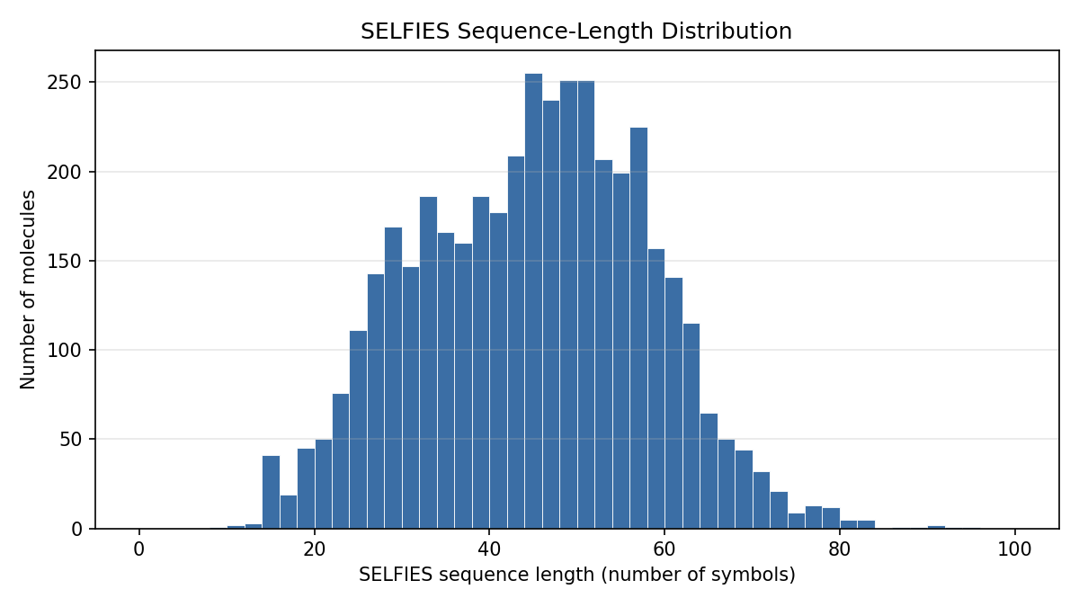
Figure 1. Distribution of SELFIES sequence lengths across the 4,194 usable molecules. The distribution is right-skewed with a mean of 44.4 symbols and a maximum of 94.

3.2 Model and Training Configuration
Table 2 lists the architecture and optimization settings used for all experiments. The graph encoder contains 182,912 parameters and the Transformer contains 1,488,886 parameters.
Component / Hyperparameter | Value
GCN layers (GCNConv) | 3
GCN hidden width / atom-embedding dimension | 192
Atom feature fields (embedding tables) | 7
Bond-order edge weights (single/double/triple/aromatic) | 1.0 / 2.0 / 3.0 / 1.5
Transformer layers / attention heads | 4 / 6
Model width / feed-forward width | 192 / 512
Shared projection dimension | 128
Contrastive temperature τ | 0.07
Loss weights (λ, γ) | 1.0, 0.25
Optimiser | AdamW (lr 3e-4, weight decay 1e-5)
Learning-rate schedule | Cosine decay
Batch size | 256
Warm-up epochs / joint epochs (max) | 15 / 40 (early stopping)
Precision / gradient clipping | Mixed (AMP) / 1.0
Table 2. Model architecture and training configuration.

3.3 Training Dynamics
Figure 2 shows the language-model warm-up. Over 15 epochs both the training and validation token losses decrease monotonically, the token accuracy rises toward approximately 0.55, and the validation perplexity falls from roughly 9.4 to about 4.2, indicating that a competent sequence model is established before alignment begins. Figure 3 shows the joint training stage. The contrastive and positive-pair losses fall sharply while the token loss remains stable, and the in-batch retrieval accuracy climbs from 0.0286 to 0.8947, demonstrating that the two encoders progressively agree without degrading language-model quality. The validation perplexity does not fall monotonically in this stage: it rises from 4.257 to a maximum of 4.358 at epoch 7 before declining to 4.044, so the language model degrades slightly while alignment is being established and only afterwards recovers past its warm-up value. Early stopping did not trigger and all forty epochs ran; the lowest validation objective occurred at epoch 37, and that checkpoint was restored for all results reported below.
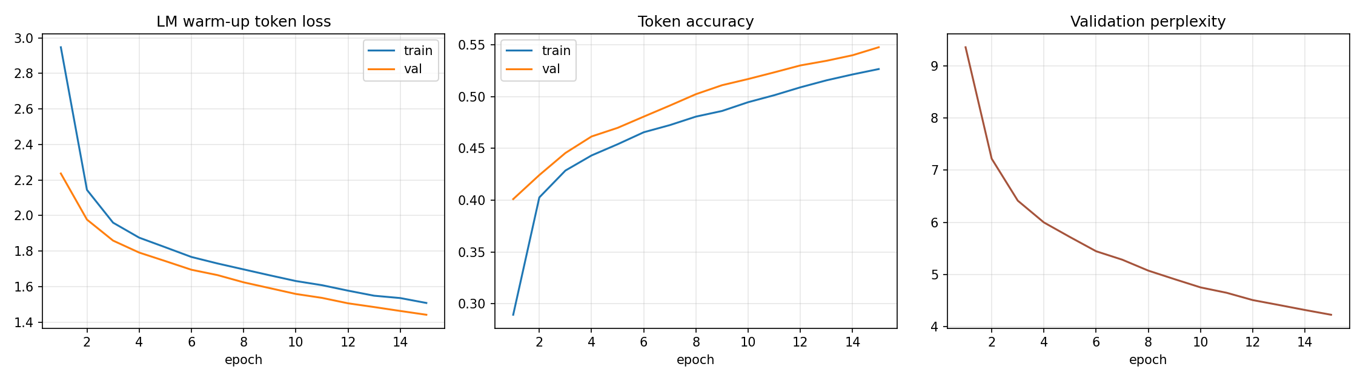
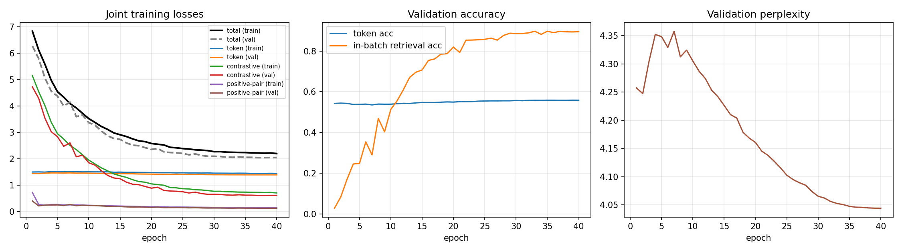
Figure 2. Language-model warm-up over 15 epochs: token loss (left), token accuracy (centre), and validation perplexity (right).

Figure 3. Joint training over the second stage: component and total losses (left), token and in-batch retrieval accuracy (centre), and validation perplexity (right).

3.4 Cross-Modal Retrieval
Table 3 reports retrieval on the 420-molecule test split. Top-1 accuracy is 0.821 graph-to-sequence and 0.831 sequence-to-graph, with Top-5 accuracies of 0.983 and 0.990 and mean ranks of 1.36 and 1.33. The average cosine similarity of matching pairs is 0.868, whereas that of non-matching pairs is 0.0001, showing that the shared space cleanly separates correct from incorrect pairings. The random-chance Top-1, Top-5 and Top-10 rates are only 0.0024, 0.0119 and 0.0238 respectively; all three are computed by the evaluation code from the test-set size rather than inserted by hand.

Direction | Top-1 | Top-5 | Top-10 | Mean rank
Graph → Sequence | 0.821 | 0.983 | 0.995 | 1.36
Sequence → Graph | 0.831 | 0.990 | 0.995 | 1.33
Random chance | 0.0024 | 0.0119 | 0.0238 | —
Table 3. Cross-modal retrieval accuracy on the test split (N = 420). Matching-pair cosine similarity = 0.868; non-matching-pair cosine similarity = 0.0001.

3.5 Generation Metrics
Table 4 and Figure 4 summarize generation at the three temperatures. RDKit validity is 1.000 at every temperature, and uniqueness, exact novelty, and structural novelty are also 1.000 throughout. The acceptance rate, by contrast, decreases from 0.933 at temperature 0.8 to 0.787 at temperature 1.2, and the mean QED declines from 0.528 to 0.451 over the same range. Both trends are monotonic across the three temperatures.
Temp. | Validity | Accept. | Unique. | Exact nov. | Struct. nov. | Mean QED
0.8 | 1.000 | 0.933 | 1.000 | 1.000 | 1.000 | 0.528
1.0 | 1.000 | 0.863 | 1.000 | 1.000 | 1.000 | 0.508
1.2 | 1.000 | 0.787 | 1.000 | 1.000 | 1.000 | 0.451
Table 4. Generation metrics by sampling temperature (300 samples each).
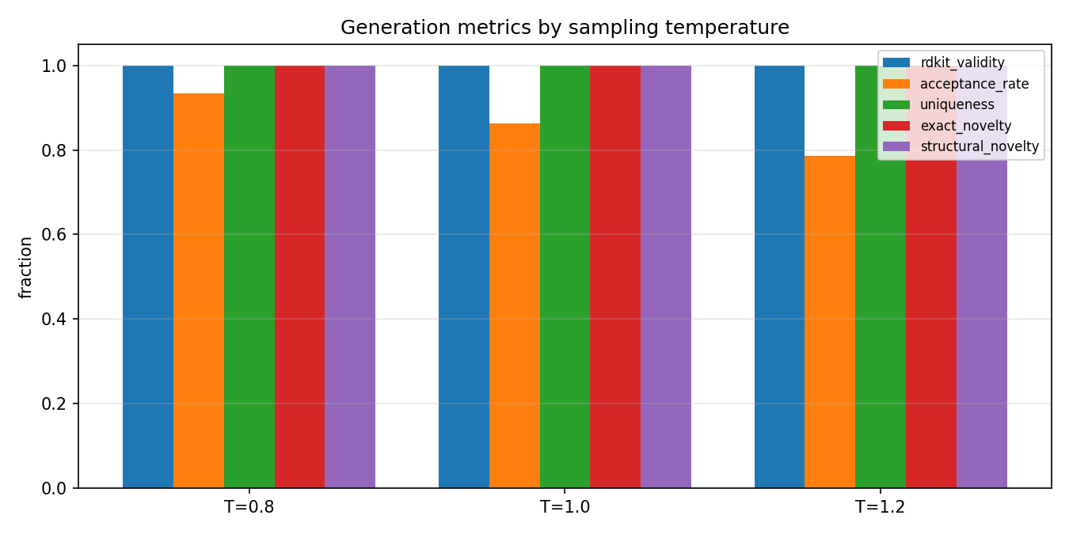
Figure 4. Generation metrics by sampling temperature. Validity, uniqueness, and both novelty measures remain at 1.0, while the acceptance rate declines as temperature increases.

3.6 Validation-Pipeline Rejection Counts
Table 5 gives the per-stage rejection counts, including the empty-output stage that the pipeline also tracks. All rejections fall into just two categories: molecules containing radical electrons and molecules whose heavy-atom count or molecular weight lies outside the accepted training range. No sample failed SELFIES decoding, parsing, sanitization, connectivity, element, formal-charge, or empty-output checks. The number of radical rejections rises steeply and monotonically with temperature, from 6 at temperature 0.8 through 18 at 1.0 to 46 at 1.2. The size-based rejections do not follow a monotonic trend: they run 14, 23 and 18, peaking at the intermediate temperature. Table 6 lists every rejected sample the pipeline retained, five for each firing stage at each temperature.
Validation stage | T = 0.8 | T = 1.0 | T = 1.2
SELFIES decode failure | 0 | 0 | 0
SMILES parse failure | 0 | 0 | 0
Sanitisation failure | 0 | 0 | 0
Multiple connected components | 0 | 0 | 0
Foreign element / dummy atom | 0 | 0 | 0
Radical electrons | 6 | 18 | 46
Heavy-atom / weight out of range | 14 | 23 | 18
Formal charge exceeds bound | 0 | 0 | 0
Empty decoded output | 0 | 0 | 0
Accepted | 280 | 259 | 236
Table 5. Rejection counts for each validation stage, by sampling temperature (300 samples each).

Temp. | Rejection stage | Decoded SMILES of the rejected sample
0.8 | Radical electrons | CCCC(C1)CCC(=O)N1C=CC2=CC=CC=C2N[NH1]
0.8 | Radical electrons | CC(=O)NC[C@H1]C=CC(C=C1C=C(C(=O)N)C2=C3C=CC=C2C=C3N1)NCC(=O)O
0.8 | Radical electrons | C1OC=CC2=CC(N[C@@H1]C=CC3=CC=C(C(N)=C23)CC4=CC=CCl)C=C4[NH1]C(=O)OC1
0.8 | Radical electrons | CC(N)C(=O)[C@@H1](OC[C@@H1]CC[C@H1]CF)OCF
0.8 | Radical electrons | O=C(O)NC=CC=C1C=C(F)C=C1[N+1]=O
0.8 | Size / weight out of range | O=CC=C(C(F)F)CF
0.8 | Size / weight out of range | CCC=CC(C=O)C=O
0.8 | Size / weight out of range | COC=CC=CC(=O)C=O
0.8 | Size / weight out of range | COC=CC=CC(CCC=C(C1=O)C2=CC3=C1OC4(C5)O)C=C(Cl)CC=C5C6(Cl)C=CC=C4CC(CCCC)=CC32CC=CC6
0.8 | Size / weight out of range | N1C(=O)C#C1
1.0 | Size / weight out of range | COC=CC=C(C=O)F
1.0 | Size / weight out of range | COC=CC#CC(=O)C=O
1.0 | Size / weight out of range | CN(C)C=O
1.0 | Size / weight out of range | CC=CC1=CNC=CC=C1
1.0 | Size / weight out of range | COC=CC(C)Cl
1.0 | Radical electrons | C=1[C@H1]([C@H1](C)[C@@H1]CC2NCCCC2N(C)C=O)C=1
1.0 | Radical electrons | CC(=O)OC[C@H1]CC[C@H1]C[C@@H1](CNC)CN1[C@H1](C(=O)N)[C@H1](C=O)C=C(C=CS1)C=C(C)PC=CCSC=N
1.0 | Radical electrons | C1OC=CC=CNC(=O)C2C(C3N[C@H1]C[C@H1]1ONNCNC=CC(=O)C=CC=C2)C3N
1.0 | Radical electrons | C12C=CC=C(C=NCC[C@@H1]C=O)C=NC1C=N2
1.0 | Radical electrons | C[C@H1]CN=C1C(=O)C=C(N)C(C=CC2=C(F)C3)=CC=C2CCC13NNC
1.2 | Size / weight out of range | O=C(O)CF
1.2 | Size / weight out of range | O=C[NH1]C=CC=C(CF)F
1.2 | Size / weight out of range | C1C=CC(C=O)O1
1.2 | Size / weight out of range | COC(=O)C=O
1.2 | Size / weight out of range | C1C(C2)C(Cl)OC1C2N
1.2 | Radical electrons | C1[C@@H1](CC[C@H1]C=NN(NCO)CO[C@H1]C)CC12CC=NC=N2
1.2 | Radical electrons | C[C@H1]C[NH1]C=C1C=CC1C
1.2 | Radical electrons | CNC(=O)[C@@H1]CC[C@@H1]1C[C@H1](N[C@H1]C[C@@H1](C[C@H1](O)C1CC[C@@H1](C)C=O)C(CCF)CF)CF
1.2 | Radical electrons | C1N(CC=NC2C3=CC4=NC=C3C=C4C=C2[C@@H1]C=C)C1O
1.2 | Radical electrons | COC=CNC(=O)[C@@H1]CC1CCC(F)C=CC1
Table 6. All thirty rejected samples retained by the validation pipeline (five per firing stage at each temperature). Only the radical-electron and size/weight stages rejected anything, so no examples exist for the remaining seven stages. The complete record is written to rejected_examples.json.

3.7 Embedding-Space Nearest-Neighbor Analysis
Table 7 lists a representative set of accepted novel molecules together with their graph-sequence cosine similarity, the identity and embedding similarity of their nearest training molecule in the combined embedding space, and their maximum Morgan-fingerprint Tanimoto similarity to any training molecule. The generated and nearest-training SMILES are reproduced in full so that every entry can be re-parsed directly from the table. Across all accepted novel molecules the maximum fingerprint similarity is low (between 0.108 and 0.119 for the twelve most novel examples), consistent with the structural-novelty rate of 1.000. The end-of-sequence fallback described in Section 2.9 was invoked 0 times, meaning every analyzed sample emitted an end-of-sequence token within the length bound; the fallback path is therefore implemented and available but was not exercised by this run.
Generated molecule (SMILES) | Nearest training molecule (SMILES) | Graph-seq cos | Nearest-train cos | Max Tanimoto
N#CC(=CC=CF)[SH]=CC=C(OC=O)[SH]=O | NS(=O)(=O)c1cc(C(=O)O)c(NCc2ccco2)cc1Cl | 0.248 | 0.659 | 0.108
CC(F)C=NC=CC1=C2C=CC3=C2N=CC1OC=C3 | COC1=CC(c2cc3ccccc3[nH]2)=N/C1=C\c1[nH]c(C)cc1C | 0.136 | 0.541 | 0.110
CC=CC=CC(CC)N(C=NCC1C=N1)C1OC=CC2C3=C=CC=CC3=CC21 | C1=CCC(c2ccc3ccccc3c2)CNC1 | 0.163 | 0.610 | 0.110
C1=COC2C=CC=CC3=CC(CC3=C1)OC=C2 | Oc1cc(OCc2ccccc2)ccn1 | 0.577 | 0.744 | 0.111
CNC=CC=C(C)NC=C(F)CF | Nc1nc(N)nc(-c2cccc(C(F)(F)F)c2)n1 | 0.345 | 0.728 | 0.111
C=NC1=CC=CCC=C1C12C=NC=CC1C2 | CC1=NC(C)(c2cccc(-c3cccnc3)c2)N=C1N | 0.412 | 0.652 | 0.115
CC=NC=CNC=CC=CC=CC(F)(F)OC | COCCCCC(=NOCCN)c1ccc(C(F)(F)F)cc1 | 0.263 | 0.527 | 0.115
CC(O)=CC=CN=CC(S)Cl | Oc1cc(Cl)cc(Cl)c1 | 0.730 | 0.786 | 0.117
O=CCC1=C2C=CC=C3CNC3=CC(C=CNC=O)NC=CCNC=C1O2 | O=C(Nc1nnn[nH]1)c1cc(Oc2ccccc2)c2ccccn2c1=O | 0.107 | 0.628 | 0.117
C=CC=CCN=CC=CC=CC=CS(N)(=O)=O | NC(=O)Nc1sc(-c2ccccc2)cc1C(N)=O | 0.450 | 0.743 | 0.118
Table 7. Ten accepted novel molecules with their full canonical SMILES, the SMILES of their nearest training molecule in the combined embedding space, their graph-sequence cosine similarity, the corresponding nearest-training embedding similarity, and their maximum Morgan-fingerprint Tanimoto similarity to the training set.
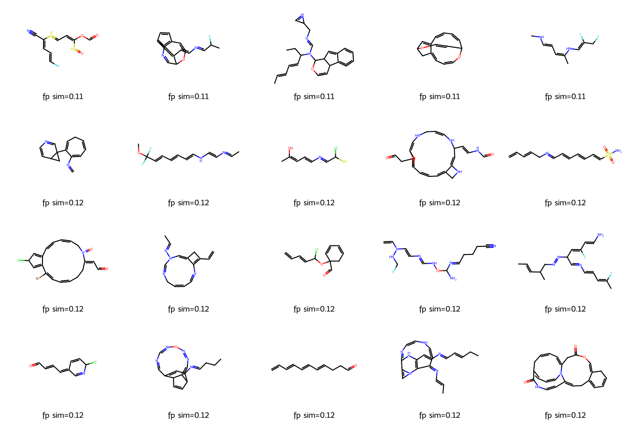
Figure 5. Twenty accepted novel molecules with the lowest fingerprint similarity to the training set, rendered with RDKit; legends show the maximum Tanimoto similarity to any training molecule.

4. Discussion

4.1 Dataset Preparation
The preparation results in Table 1 are cleaner than would be expected for an arbitrary chemical dataset: no molecule failed parsing, encoding, or duplication checks. This is explained by the provenance of the data, since the MoleculeNet Lipophilicity release is already curated and deduplicated, so the pipeline correctly reports zero removals in those categories rather than fabricating losses. The only reduction, six molecules with SELFIES longer than 100 symbols, is a deliberate consequence of the context-length bound and removes only 0.14% of the data. The right-skewed length distribution in Figure 1, with most molecules between roughly 25 and 60 symbols and a thin tail toward 94, confirms that a 100-symbol cap discards very little information while keeping the Transformer sequence length manageable.

4.2 Training Dynamics
The warm-up curves in Figure 2 behave as expected for language-model pre-training: monotonically decreasing loss, rising token accuracy, and falling perplexity, with no sign of over-fitting. It should be noted that the validation curves in Figure 2 do not merely track the training curves but sit consistently on the better side of them: the validation token loss lies below the training loss and the validation token accuracy above the training accuracy at every epoch. This ordering is expected rather than anomalous, and it arises from how the two quantities are measured. Dropout is active while training but disabled at evaluation, so the training statistics describe a stochastically degraded model whereas the validation statistics describe the full one. In addition, the training figures are running averages accumulated across an entire epoch and therefore include the early batches of that epoch, while validation is computed once at the end of the epoch on the already-updated weights, leaving the training average lagged by roughly half an epoch of optimization. The gap is consequently a measurement artefact, and the fact that it remains stable across all fifteen epochs, rather than widening, is what indicates that the model is not over-fitting. A token accuracy near 0.55 is reasonable for SELFIES, where the next symbol is often only weakly constrained by context. The more informative behavior appears in the joint stage (Figure 3): the contrastive and positive-pair losses fall by factors of roughly seven and five respectively, while the token loss stays essentially flat. This is the desired outcome, because it demonstrates that alignment is achieved without sacrificing generative quality; the two objectives are compatible rather than competing. The in-batch retrieval accuracy rising to 0.8947 during training foreshadows the strong held-out retrieval reported next. The perplexity trajectory, however, is not a simple improvement and should not be described as one: validation perplexity first worsens from 4.257 to 4.358 over the opening epochs, and only then falls to 4.044. The interpretation is that introducing the alignment terms initially competes with the language-model objective, and that the competition resolves as the shared space stabilizes. The net effect across the stage is a small improvement over the warm-up value of 4.226, but the intermediate degradation is real and visible in Figure 3.

4.3 Cross-Modal Retrieval
Retrieval is the primary measure of whether the two views were successfully aligned, and the results in Table 3 are strong. A Top-1 accuracy of 0.821 and 0.831 means that, for a large majority of test molecules, the single closest candidate in the other modality is the correct counterpart, and mean ranks of 1.36 and 1.33 indicate that when the top candidate is wrong, the correct one is almost always second. The near-perfect separation between matching-pair cosine similarity (0.868) and non-matching-pair cosine similarity (0.0001) shows that the contrastive objective drove corresponding embeddings together while pushing unrelated ones to near-orthogonality. Compared with the random-chance Top-1 of 0.0024, the model performs roughly 345 times better than chance, so the alignment is both statistically and practically significant. The two directions are close but not identical: sequence-to-graph exceeds graph-to-sequence by 0.010 at Top-1 and by 0.007 at Top-5. A gap of this size is within the run-to-run variation discussed in Section 4.8, so it is not evidence that one encoder dominates the shared space, but neither is it safe to describe the two directions as exactly symmetric. These results directly answer the first research question in the affirmative: the graph and sequence modalities can be aligned so that one reliably retrieves the other.

4.4 Generation Quality and the Meaning of Validity
The generation results in Table 4 must be interpreted carefully. A validity of exactly 1.000 at every temperature is expected and is not evidence of a strong generator: because SELFIES strings decode to syntactically valid molecules by construction, perfect RDKit validity is the floor rather than an achievement. The genuinely informative quantity is the acceptance rate, which applies the full chemical pipeline and therefore falls below one. Its clear downward trend with temperature, from 0.933 at 0.8 to 0.787 at 1.2, matches the expectation that higher-temperature sampling produces more adventurous and less chemically conservative structures. The rejection breakdown in Table 5 makes the mechanism explicit, and it attributes the entire trend to one stage: radical-containing molecules rise from 6 to 46, indicating that aggressive sampling increasingly produces atoms with unpaired electrons. The size-based stage does not contribute to the trend at all, since its counts of 14, 23 and 18 peak at the intermediate temperature rather than rising. The mean QED, which declines from 0.528 to 0.451, corroborates the overall interpretation, since higher-temperature molecules are on average less drug-like. Together these observations demonstrate the classic quality-versus-diversity trade-off of temperature sampling, and they show why acceptance rate, radical counts, and QED are more meaningful indicators than validity alone.
Uniqueness, exact novelty, and structural novelty are all 1.000. High novelty is easy to attain and, on its own, is not necessarily desirable: the fact that every accepted molecule has a maximum training Tanimoto similarity below 0.85, and that the most novel examples in Table 7 and Figure 5 sit near 0.11, indicates that the generator does not merely memorize or lightly perturb training molecules but instead explores regions of chemical space that are structurally distant from the lipophilicity training set. The accompanying visual inspection of Figure 5 tempers this positive reading: several of the most novel structures contain cumulated or strained motifs and unusual heteroatom arrangements that, while passing the automated checks, are chemically questionable. This reinforces the central lesson that formal validity and even fingerprint-level novelty do not guarantee synthesizability or stability, and that automated pipelines should be complemented by property-based screening such as QED.
The rejected samples in Table 6 clarify what the two firing stages actually remove, and the size stage behaves differently from what its name suggests. Of the fifteen retained size rejections, fourteen were rejected for falling below the lower bound of the training distribution and only one for exceeding the upper bound, so the stage is predominantly discarding small fragments rather than oversized structures. The clearest illustration is the sample CN(C)C=O rejected at temperature 1.0, which is dimethylformamide, an entirely ordinary and stable compound; it fails only because its five heavy atoms lie below the first-percentile bound of eleven heavy atoms in the training set. This stage is therefore a distribution-matching filter rather than a chemical-validity filter: it asks whether a sample resembles the lipophilicity training data, not whether it is a real molecule. The radical rejections, by contrast, are genuine chemical defects, each carrying one or two unpaired electrons, and they span heavy-atom counts from ten to thirty-eight, so they are not a size-related artefact.

4.5 Embedding-Space Analysis
Table 7 situates the generated molecules relative to the training manifold. The nearest-training embedding similarities are moderate (0.527 to 0.798), while the fingerprint Tanimoto similarities are uniformly low (0.108 to 0.119), which is internally consistent: the learned embedding space captures a coarser, more semantic notion of similarity than a bit-level fingerprint, so a generated molecule can be embedded near a training molecule while remaining structurally distinct. The graph-sequence cosine similarity varies widely across examples, from 0.107 to 0.730, against an average of 0.868 for real test molecules. The two encoders therefore agree substantially less on generated molecules than on real ones, which is unsurprising because these samples lie outside the training distribution where the learned alignment is not guaranteed to hold. It should be stated explicitly that no negative graph-sequence similarity occurs in this run; every value is positive, so the encoders disagree in degree rather than in direction. This analysis provides useful evidence that the generator produces genuinely out-of-distribution samples rather than near-duplicates.

4.6 Limitations
Three limitations should be noted. First, because validity is guaranteed by SELFIES, the acceptance pipeline and QED, rather than validity, carry the burden of quality assessment; even so, some accepted molecules remain chemically implausible on visual inspection, so a stricter filter or a synthesizability score would strengthen the evaluation. Second, the perfect structural-novelty rate, combined with modest QED values, suggests that the generator drifts away from realistic lipophilicity chemistry; conditioning generation on the experimental property or adding a distribution-matching term could keep samples closer to the target chemical space. Third, retrieval is evaluated within a fixed test set, so the reported accuracies describe in-distribution matching and may not extend to arbitrary external molecules.

4.7 Conceptual Discussion
Sections 4.1 to 4.6 interpret the measured results. This section addresses the conceptual questions raised by the assignment.
Global pooling is required because a molecular graph has neither a canonical atom ordering nor a fixed atom count. After three propagation layers the encoder holds one hidden vector per atom, so a fifteen-atom molecule is a 15 x 192 matrix and a forty-five-atom molecule a 45 x 192 matrix, whereas Equation 5 requires exactly one fixed-length vector per molecule. Any operation consuming that matrix in index order would also make the embedding depend on the arbitrary sequence in which RDKit enumerated the atoms. Mean pooling resolves both difficulties at once: it maps a variable number of atoms onto a single 192-dimensional vector, and because summation is commutative the result is invariant to atom permutation. Averaging rather than summing also prevents the embedding norm from growing with molecular size.
The scalar bond weight is only an approximation of complete bond information because GCNConv accepts one number per edge, so the whole chemistry of a bond is compressed into a single value. The weight acts as a magnitude rather than a type: the layer can only rescale a message, so a double bond becomes a single bond of twice the influence, which has no chemical justification. Properties distinguishing bonds of identical order are discarded entirely, including ring membership, conjugation, rotatability, and E/Z stereochemistry, and the value 1.5 assigned to aromatic bonds is a modelling convention rather than a measured bond order. Atom-level stereochemistry survives through the chirality embedding field of Section 2.2, but bond-level stereochemistry is not represented at all; an architecture consuming edge feature vectors could condition the message transformation on bond type instead of merely scaling it.
Causal masking is necessary so that the conditioning available during training matches that available during generation. Equation 3 asks the model to predict a token from its predecessors, but a Transformer encoder is bidirectional by default, so without a mask position t would attend to itself and to every later token. The task would degenerate into copying, driving the loss toward zero while teaching nothing about sequential structure, and at sampling time the model would face a conditioning distribution it had never observed. The upper-triangular mask of negative infinity guarantees that each position sees only its own past, while the padding mask prevents real tokens from attending to positions that exist only because sequences of unequal length were batched together.
Next-token prediction enables autoregressive generation because it fits a factorization of the joint sequence distribution into a product of per-position conditionals. Training with Equation 3 estimates all of them simultaneously, and sampling reverses the factorization: begin from the beginning-of-sequence token, draw one token, append it, re-run the model, and repeat until the end-of-sequence token is emitted or the length bound is reached. No further generative machinery is needed and no ground-truth continuation is ever supplied, which is possible only because causal masking made the training-time conditionals identical to those used at sampling time.
A separate language-model warm-up is useful because the contrastive loss is meaningful only once the end-of-sequence hidden state genuinely summarizes a molecule. At initialization that state is effectively random, so aligning the graph encoder to it would drive the GCN toward noise that must later be unlearned. Figure 3 supports this directly: the token loss enters the joint stage already near its converged value and stays essentially flat, so the joint stage is spent almost entirely on alignment rather than on learning the language model and the shared space at once.
Batch size affects the number of contrastive negatives directly, because in Equation 5 the negatives for a molecule are the other members of its mini-batch. At the batch size of 256 used here, each positive competes against 255 negatives; halving the batch halves the negatives and lowers the floor of the InfoNCE loss, yielding a smaller value that reflects an easier task rather than a better model. A larger batch approximates the full-dataset softmax more closely and gives a harder, more informative signal, which also explains why the in-batch retrieval accuracy of 0.8947 in Figure 3 is not directly comparable to the test Top-1 accuracy of 0.821 in Table 3: the former ranks against at most 255 distractors and the latter against 419.
Exact novelty does not prevent near-memorization because it compares canonical SMILES strings and is therefore a test of string identity rather than structural difference. A molecule differing from a training molecule by one methyl group, a halogen substitution, or an inverted stereocentre yields a different canonical string and counts as fully novel while remaining a memorized scaffold in practice. The exact novelty of 1.000 in Table 4 therefore carries little information alone, and the fingerprint criterion is required: Tanimoto similarity over radius-two Morgan fingerprints compares substructure inventories, so near-duplicates score highly even when their strings differ. The maximum training-set similarity of at most 0.119 in Table 7 is what actually licenses the conclusion that the generator explores rather than memorizes.
Finally, SELFIES and RDKit validity do not establish stability, synthesizability, safety, biological activity, environmental acceptability, or medical usefulness, because the pipeline of Section 2.8 tests only whether a string denotes a well-formed molecular graph. SELFIES guarantees syntactic decodability by construction, and RDKit sanitization verifies valence, kekulisation, and aromaticity. Neither examines thermodynamic or kinetic stability, and Table 7 contains motifs that satisfy valence rules yet correspond to species one would not expect to isolate. Synthesizability is never assessed, as no retrosynthetic or reagent-availability criterion is applied. Safety, biological activity, and environmental acceptability are properties of a molecule in contact with a biological or ecological system and cannot be inferred from a connectivity table, requiring assay data, toxicological testing, and ultimately clinical evidence. The mean QED of Table 4 is a heuristic resemblance score to marketed oral drugs rather than a measurement of any of these properties, and is reported as a descriptive statistic only. The accepted molecules should therefore be regarded as formally valid candidates for further screening, and as nothing more.

4.8 Expected Versus Observed
Because the results reported here come from a repeated execution of the same pipeline, each measured quantity can be checked against the behavior that was anticipated for it. Table 8 records that comparison. Six entries did not match the expectation, and each is discussed at the point where it arises; they are collected here so that no discrepancy is left implicit.
Result | What was expected | What was observed | Verdict
Dataset preparation (Table 1) | Identical to the earlier run; the pipeline is seeded and CPU-bound | All sixteen fields identical | Match
SELFIES lengths (Figure 1) | Right-skewed, well inside the 100-symbol cap | Right-skewed, max 94, only 6 molecules cut | Match
Warm-up losses (Figure 2) | Smooth monotonic decrease, no over-fitting | Decrease at every one of 15 epochs; perplexity 9.359 to 4.226 | Match
Warm-up accuracy (Figure 2) | Rising toward roughly 0.55 | Reached 0.5477 | Match
Validation below training (Figure 2) | Validation slightly worse than training | Validation better at all 15 epochs; explained in Section 4.2 | Mismatch, explained
Joint alignment losses (Figure 3) | Large fall in both alignment terms, flat token loss | Contrastive down 7.2x, positive-pair down 4.6x, token loss down 3.5% | Match
Joint perplexity (Figure 3) | Monotonic improvement | Rises to 4.358 at epoch 7, then falls to 4.044 | Mismatch
Early stopping (Section 2.6) | May halt training before 40 epochs | Did not trigger; all 40 epochs ran, best checkpoint at epoch 37 | No effect
Retrieval Top-1 (Table 3) | Between 0.80 and 0.86 in both directions | 0.821 and 0.831 | Match
Retrieval symmetry (Table 3) | Both directions equal, as in the earlier run | Top-5 differs: 0.983 against 0.990 | Mismatch
Random chance (Table 3) | Derived by the code from the test-set size | 0.0024 / 0.0119 / 0.0238 | Match
RDKit validity (Table 4) | 1.000 everywhere, guaranteed by SELFIES | 1.000 at all three temperatures | Match
Acceptance rate (Table 4) | Falls as temperature rises | 0.933 to 0.787, monotonic | Match
Mean QED (Table 4) | Falls as temperature rises | 0.528 to 0.451, monotonic | Match
Radical rejections (Table 5) | Rise steeply with temperature | 6, 18, 46 | Match
Size rejections (Table 5) | Rise with temperature, as in the earlier run | 14, 23, 18; peaks in the middle | Mismatch
Rejected samples (Table 6) | Five per firing stage per temperature | 30 retained, split evenly between the two firing stages | Match
Size-rejection direction (Table 6) | A mixture of oversized and undersized samples | 14 of 15 rejected for being too small | Mismatch
Fingerprint novelty (Table 7) | Around 0.11, far below the 0.85 threshold | 0.108 to 0.119 | Match
Graph-sequence agreement (Table 7) | Wide spread including negative values, as before | 0.107 to 0.730; no negative values | Mismatch
Generated structures (Figure 5) | Formally valid but visually implausible in places | Confirmed on inspection; strained rings and unusual heteroatom placement | Match
End-of-sequence fallback | Rarely or never needed | Invoked 0 times | Match, untested
Table 8. Expected against observed outcome for every table, figure and headline claim in this report.
Two of the six mismatches change a conclusion rather than a number. The joint-stage perplexity does not improve monotonically, so the earlier characterization of alignment as costless to the language model is too strong; the correct statement is that alignment imposes a temporary cost that is later recovered. The size-rejection counts do not trend with temperature, so only the radical stage supports the quality-versus-diversity argument of Section 4.4. The remaining four are matters of degree: validation curves sitting above training curves is a measurement artefact, the Top-5 asymmetry and the absence of negative graph-sequence values are both within run-to-run variation, and the direction of the size rejections was simply not anticipated.

4.9 Reproducibility Across Runs
The pipeline was executed twice on identical code with a fixed seed and with cuDNN placed in deterministic mode. The two executions did not agree completely, and the pattern of disagreement is informative. The dataset stage reproduced exactly, which is expected because it is seeded and runs entirely on the CPU. The language-model warm-up also reproduced exactly, with every per-epoch training loss matching to four decimal places across both runs. The joint stage did not reproduce exactly: the final contrastive loss moved from 0.7085 to 0.7130 and the final in-batch retrieval accuracy from 0.8987 to 0.8947.
This split follows the mechanism rather than contradicting it. The warm-up stage trains only the Transformer, whose operations are deterministic once cuDNN is constrained. The joint stage additionally trains the graph encoder, whose global mean pooling is implemented as a scatter reduction that accumulates in non-deterministic order on a GPU. Exact reproducibility is therefore not attainable for the joint stage under this implementation, and the differences observed are consistent in magnitude with that source. All downstream quantities, including retrieval and generation, inherit this variability, which is why Table 8 treats differences of a few thousandths as run-to-run variation rather than as findings.

5. Conclusion
This work implemented and evaluated a dual-view molecular model that aligns a graph representation from a three-layer GCN with a sequence representation from a four-layer Transformer, using a combined next-token, contrastive, and positive-pair objective, and that generates and validates new molecules. On the Lipophilicity dataset, after retaining 4,194 clean molecules, the system achieved strong cross-modal alignment, with test Top-1 retrieval accuracy of 0.821 and 0.831 in the two directions, mean ranks of 1.36 and 1.33, and near-perfect separation of matching from non-matching pairs. Generation produced fully valid and highly novel molecules at all three temperatures, with acceptance rate falling from 0.933 to 0.787 and mean drug-likeness from 0.528 to 0.451 as temperature increased, driven entirely by radical-containing structures rising from 6 to 46. The principal findings are that the graph and sequence views can be aligned effectively without harming language-model quality, and that formal validity is an insufficient measure of generative quality, which is better captured by the acceptance pipeline, radical counts, and QED. Future work should condition generation on the target property, incorporate synthesizability and distribution-matching criteria, and evaluate retrieval against external molecule collections to test generalization beyond the held-out split.

